NAME: Naveed Ullah
SECTION: SE-1B
ROLL-NO : 26P-3053
COURSE Details
- Basic concept of Version Control System (VCS).
- Brief note Git and Github, their work and uses.
- Idea of Repository or repo.
- Creating github user id.
- Core concept of C language, their purpose and characteristic.
- How C execute a program etc.
- Functions and variables.

Task No….01 Roll No …26P-3053

- This is my GitHub link:
- [https://github.com/NaveedUllah-art/PF-Lab02.git]
- Picture of repository and menu.
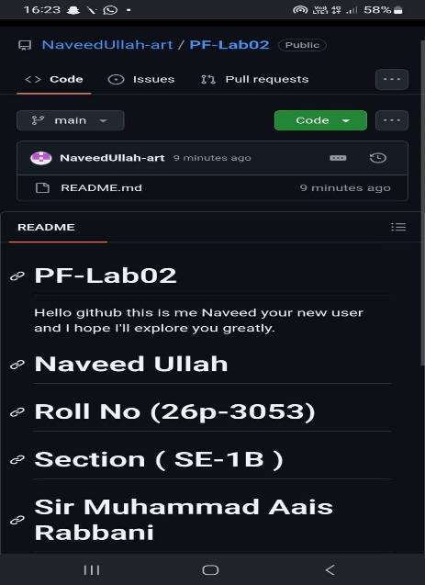
- Menu :
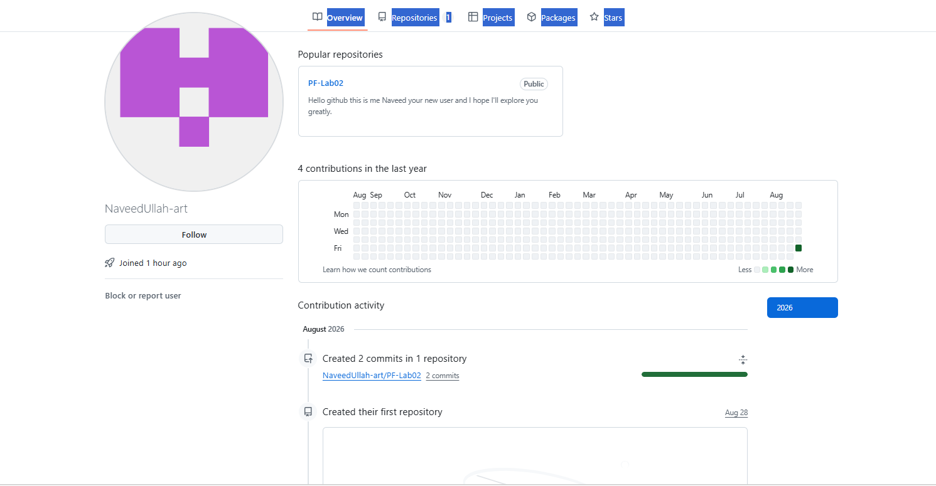

TASK…02 ROLL-NO…26p-3053

- Code to show students profile card.

#include <iostream>
int main () {
int Batch_Year =2026;
char Section = 'B';
float Test_score =62.5;
double Fees =26800;
printf("\n");
printf("\n=================================================\n");
printf("\n");
printf("\tFAST-NUCES STUDENT PROFILE CARD");
printf("\n");
printf("\n=================================================\n");
printf("\tBatch Year: %d\n\t",Batch_Year);
printf("Section: %c\n\t",Section);
printf("Test_score: %f\n\t",Test_score);
printf("Fees: %f\n\t",Fees);
printf("Motto:\t Small daily steps lead to big success\n");
return 0;
}
- Compiled picture: 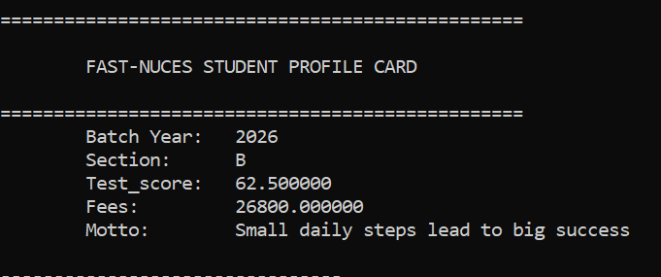

TASK 03 Roll NO 26P3053
- Code for the sake of proper usage of escape sequences.
#include <iostream>
int main() {
printf("\n");
printf("\n======== C ESCAPE SEQUENCES REFERENCE ===========\n");
printf("\n ");
printf("1. To print a double quote, write: \\\" \n" );
printf("2. To print a literal backslash, write: \\\\ \n");
printf("3. To insert a new line break, write: \\n \n");
printf("4. To insert horizontal tab stop, write: \\t \n");
printf("5. To print a percentage sign, write: \%%% \n");
return 0;
}

- Pictorial description.
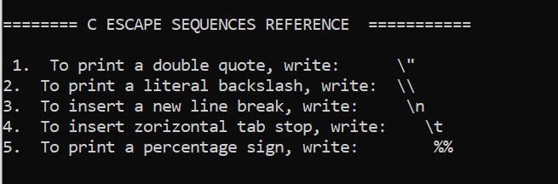

TASK 04 ROLL NO 26P-3053
- Coding mainly focuses on sizeof operator.
#include <stdio.h>
int main() {
char w = 'M';
int x= 50;
float y= 3.7654;
double z = 30.5432;
printf("\n");
printf("\ttype\tvalue\t size\n");
printf("\n--------------------------------------\n");
printf("\tchar\t %c\t %ubytes(s)\n", w, sizeof(w));
printf("\tint\t %d\t %ubytes(s)\n", x, sizeof(x));
printf("\tfloat\t %f\t %ubytes(s)\n", y,sizeof(y));
printf("\tdouble\t %f\t %ubytes(s)", z,sizeof(z));
return 0;
}
- Code compiled form.

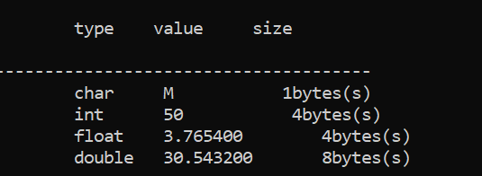

Task 05 ROLL NO 26P-3053
- A simple program for temperature conversion.
#include <stdio.h>
int main (){
float Celsius =37.5;
float Fahrenhiet, Kelvin;
Fahrenhiet =(Celsius*9.0 / 5.0)+32.0;
Kelvin = Celsius+273.15;
printf("\n");
printf(" ======TEMPERATURE CONVERTION========\n\n");
printf(" Temperature in Celsius:\t\t %.2f k\n", Celsius);
printf(" Temperature in Fahrenhiet:\t\t%.2f F\n", Fahrenhiet);
printf(" Temperature in Kelvin: \t\t%.2f K\n", Kelvin);
return 0;
}
- Compiled form:
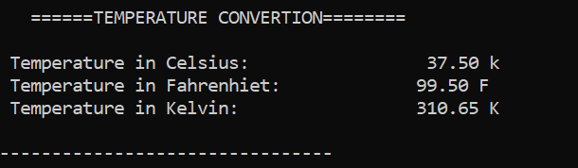

TASK 06 ROLL NO 26P-3053
- Code for Circle geometry report.
#include <stdio.h>
int main(){
float Radius =7.5;
float pi =3.14159;
float Diameter, Circumference, Area;
Diameter = 2*Radius;
Circumference =2*pi*Radius;
Area = pi*Radius*Radius;
printf("\n");
printf(" ====== CIRCLE GEOMETRY REPORT ========\n\n");
printf(" Given Radius :\t\t %.3f cm\n", Radius);
printf(" Culculated Diameter:\t\t%.3f cm\n", Diameter);
printf(" Culculated Circumference:\t%.3f cm\n", Circumference);
printf(" Culculated Area: \t\t%.3f sq.cm\n", Area);
printf(" =========================================\n");
return 0;
}
- Pictorial form of compiled program:
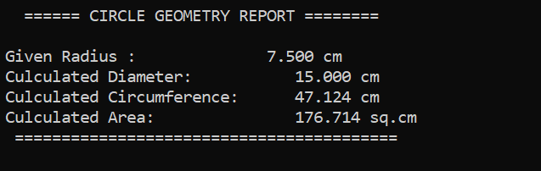

TASK 07 ROLL NO 26P-3053
- Kinematic motion report in code form.
#include <stdio.h>
int main(){
float vi =12.5;
float a =3.2;
float t = 6.0;
float vf, s;
vf = vi+(a*t);
s = (vi*t)+(0.5*a*t*t);
printf("\n");
printf(" ====== KINEMETIC MOTION REPORT ========\n\n");
printf(" Initial velocity (vi) :\t %.2f m/s\n",vi );
printf(" Acceleration (a):\t\t%.2f m/s^2\n",a );
printf(" Time elapsed (t):\t\t\t%.2f s\n ",t );
printf("----------------------------------------------\n");
printf(" Culculated final velocity(vf):\t\t%.2f m/s\n",vf);
printf(" Culculated distance(s):\t\t%.2f s\n",s);
return 0;
}
- Picture of compiled form:
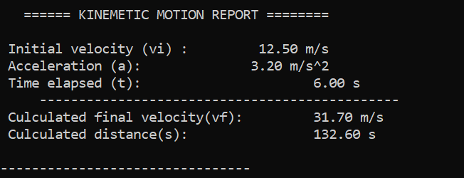

TASK 08 ROLL NO 26P-3053
- Code for how to find simple interest.

#include <stdio.h>
int main (){
// I use single alphabets for clearance
// P= principal amount, R=rate of interest
// T=time, I= total simple interest
// A= total payable amount, M= monthly installment.
double P =250000.0;
float R =8.5;
int T =3;
float I, A, M;
I =(P*R*T);
A =P+I;
M =A/(T*12);
printf("\n");
printf("========= BANK LOAN INTEREST SUMMARY ========\n\n");
printf(" principal amount(P):\t PKR%.2f \n",P );
printf(" Rate of interest(R):\t\t%.2f %\n", R);
printf(" Time (t):\t\t\t%.2f years\n ",T );
printf("----------------------------------------------\n");
printf(" Total simple interst(I):\t\tPKR%.2f \n",I);
printf(" Total payable amount(A):\t\tPKR%.2f \n",A);
printf(" Monthly installment (m):\t\tPKR%.2f \n",M);
printf("==================================================\n");
return 0;
}
- Picture form of compiled program.
- 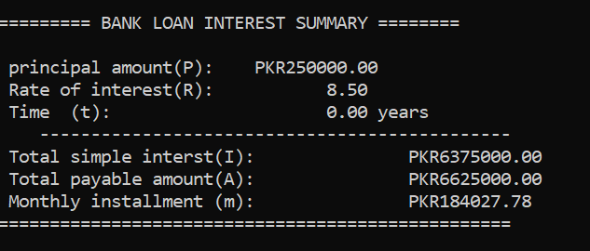

Task 09 ROLL NO 26P-3053
- Code to show monthly salary slip.
#include <stdio.h>
int main (){
double basic_salery =90000.0;
double HRA, MA, GS, ITD, NS;
HRA =(0.20*basic_salery);
MA =(0.10*basic_salery);
GS = basic_salery+HRA+MA;
ITD =(0.05*GS);
NS = GS-ITD;
printf("\n");
printf("========= MONTHLY SALERY SLIP ========\n\n");
printf(" Basic salery:\t\tPKR%.2f \n",basic_salery);
printf(" House rent allowence:\tPKR%.2f\n", HRA);
printf(" Medical allowence:\tPKR%.2f \n ",MA );
printf("----------------------------------------------\n");
printf(" Gross salery:\t\tPKR%.2f \n",GS);
printf(" Tex deduction:\t\tPKR%.2f \n",ITD);
printf("-----------------------------------------------\n");
printf(" Net payable Salery:\tPKR%.2f \n",NS);
printf("================================================\n");
return 0;
}
- Screenshot of a compiled code:

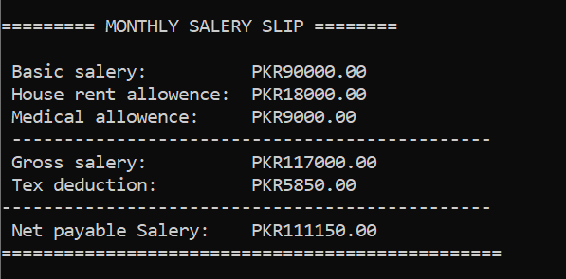

TASK 10 ROLL NO 26P-3053
- Code to show academic report.

#include <stdio.h>
int main () {
char c1[] = "Programming Funda.";
char c2[] = "Calculus";
char c3[] = "Applied Physics";
float m1 = 88.0, m2 = 76.5, m3 = 82.0;
int cr1 = 3, cr2 = 3, cr3 = 2;
float totalWeight, weightAvg;
int totalCredits;
totalWeight = (m1 * cr1) + (m2 * cr2) + (m3 * cr3);
totalCredits = cr1 + cr2 + cr3;
weightAvg = totalWeight / totalCredits;
printf("\n");
printf("================ SEMESTER ACADEMIC REPORT =================\n");
printf("\tCourse\t\t\tCredit Hours\tObtained Marks\n");
printf("------------------------------------------------------------\n");

printf("\t%s\t%d\t\t%.2f\n", c1, cr1, m1);
printf("\t%s\t\t%d\t\t%.2f\n", c2, cr2, m2);
printf("\t%s\t\t%d\t\t%.2f\n", c3, cr3, m3);

printf("------------------------------------------------------------\n");
printf("\tTotal Credits: %d\tWeight Average: %.2f%%\n", totalCredits, weightAvg);
printf("============================================================\n");

return 0;
}
- Picture of compiled form.
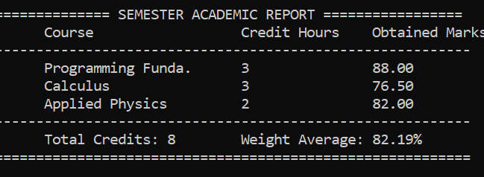

Task 11 ROLL NO 26P-3053
- Code to show cafeteria receipt.
#include <stdio.h>
int main () {
// through some sort of guidence
char item1[] = "\tTea";
char item2[] = "\tSamosa";
char item3[] = "Chicken Roll";
int qty1 = 3, qty2 = 4, qty3 = 2;
float price1 = 60.00, price2 = 40.50, price3 = 120.00;
float subtea, subsamosa,subroll,subtotal,gst,grandtotal;
subtea = qty1 * price1;
subsamosa = qty2 * price2;
subroll = qty3 * price3;
subtotal = subtea + subsamosa + subroll;
gst = subtotal * 0.16;
grandtotal = subtotal + gst;
printf("\n");
printf("================ FAST CAFETERIA RECEIPT =================\n");
printf("\n");
printf("\tItem\t\tQty\tUnit Price (PKR)\tSubtotal (PKR)\n");
printf("------------------------------------------------------------\n");

printf("\t%s\t%d\t%.2f\t\t%.2f\n", item1, qty1, price1, subtea);
printf("\t%s\t%d\t%.2f\t\t%.2f\n", item2, qty2, price2, subsamosa);
printf("\t%s\t%d\t%.2f\t\t%.2f\n", item3, qty3, price3, subroll);

printf("------------------------------------------------------------\n");
printf("\tSubtotal:\t\t\tPKR %.2f\n", subtotal);
printf("\tGST (16%%):\t\t\tPKR %.2f\n", gst);
printf("------------------------------------------------------------\n");
printf("\tGrand Total:\t\t\t\tPKR %.2f\n", grandtotal);
printf("================ THANK YOU FOR YOUR VISIT ================\n");

return 0;
}
- Screenshot of compiled form:

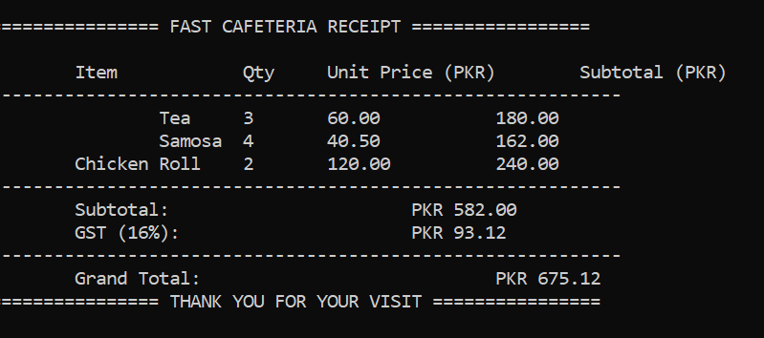

---------------------------------------THE END ---------------------------------------------

